Class Assignment

Tech Specs

Art Ammirati & Roderick Tatom

Marion Technical College

1. Purpose and Overview
   1. Roman numeral conversion application, allow users to input either a Roman Numerals or Arabic integer, the resulting output is a conversion to the opposite number system.
   2. Roman numeral converter is to be user friendly and intended to be used by all age groups.
   3. The application maybe used as a quick reference for learning the symbols of the Roman Numeral System and their corresponding value and/or making quick conversions between the two systems for professional work or personal use.
2. Development Summary
   1. Planning and requirements analysis documentation has been created with goals and deliverables specified.
   2. The requested program will be developed for Windows based PC’s using C# Forms. Furthermore the mobile app, including windows user interface will be developed with Xamarin using virtual studio.
   3. Once the code has been written, the student developers will analyze the code and make comments in the code for identifying the processes and making future improvements easier.
   4. Next the application will be tested by other students assigned by the instructor. Once the code has been signed off by the tester and any final software configurations made, the application will go live on the internet and app stores for consumers.
3. References
   1. Appendix A – Windows Form Design
   2. Appendix B – Program Flow
   3. Appendix C – Agile Software Development
4. Definitions
   1. Microsoft .NET Framework - [Software framework](https://en.wikipedia.org/wiki/Software_framework) developed by [Microsoft](https://en.wikipedia.org/wiki/Microsoft) that runs software primarily on [Microsoft Windows](https://en.wikipedia.org/wiki/Microsoft_Windows).
   2. GUI (Graphical User Interface ) – Type of [user interface](https://en.wikipedia.org/wiki/User_interface) that allows [users](https://en.wikipedia.org/wiki/User_(computing)) to [interact with electronic devices](https://en.wikipedia.org/wiki/Human%E2%80%93computer_interaction) through graphical [icons](https://en.wikipedia.org/wiki/Computer_icon) and visual indicators instead of [text-based user interfaces](https://en.wikipedia.org/wiki/Text-based_user_interface),
   3. Windows Forms - (WinForms) is a graphical (GUI) class library included as a part of Microsoft [.NET Framework](https://en.wikipedia.org/wiki/.NET_Framework) providing a platform to write rich client applications for desktop, laptop, and tablet PCs.
   4. Xamarin - [C#](https://en.wikipedia.org/wiki/C_Sharp_(programming_language))-shared codebase, developers can use Xamarin tools to write [native](https://en.wikipedia.org/wiki/Native_(computing)) [Android](https://en.wikipedia.org/wiki/Android_(operating_system)), [iOS](https://en.wikipedia.org/wiki/IOS), and [Windows](https://en.wikipedia.org/wiki/Windows) [apps](https://en.wikipedia.org/wiki/Mobile_app) with native [user interfaces](https://en.wikipedia.org/wiki/User_interface) and share code across multiple platforms, including [Windows](https://en.wikipedia.org/wiki/Windows) and [macOS](https://en.wikipedia.org/wiki/MacOS" \o "MacOS).
5. Deployment and Packaging
   1. This program will be available free to download on Github, the mobile device app on the windows app store.
6. Security
   1. This program will not feature any security
7. Data
   1. This program will generate the opposite format for the inputted value.
8. Program Flow
   1. When the user runs the program, they will be prompted with a form that contains a text box. The text box will have a label associated with it to indicate what sort of value that the user should supply. This value will either be an Arabic or Roman numeral. After the value is supplied, a label below the text box will display the opposite format of the inputted value. The program will act as a converter.
   2. Roman Numeral TextBox
      1. The text box user will enter in a Roman numeral that will be converted to an Arabic number.
   3. Calculate Button
      1. The button that the user will click in order to have the program convert the supplied value in RomanNumeralTextBox to an Arabic number in the OutputTextBox.
   4. Output TextBox
      1. The text box in which the converted value will be displayed.

**Appendix A – Form Design**

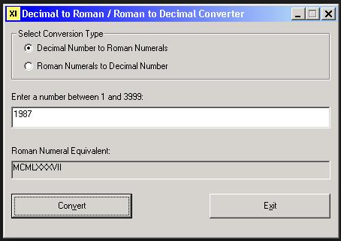

**Appendix C – Program Flow**

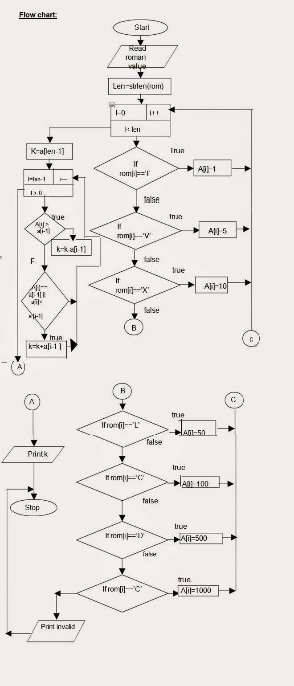

**Appendix C – Agile Software Development**

